Jairus Anderson

Utah state university  Dr. Rosenberg | Water Resources Systems Analysis | 09/14/2020

Farmer Joe’s Optimal Land use Part II

**Introduction:**

An aqueduct constructed to supply water to industrial users has an excess capacity in the months of June, July, and August of 14,000 acft, 18,000 acft, and 6,000 acft, respectively. It is proposed to develop not more than 10,000 acres of new land by utilizing the excess aqueduct capacity for irrigation water deliveries. Two crops, hay and grain, are to be grown. Solve by Excel and Gams

Their monthly water requirements and expected net returns are given in the following table:

|  |  |  |  |  |
| --- | --- | --- | --- | --- |
| Monthly Water Requirement (acft/acre)  June July August Return, $/acre | | | | |
| Hay | 2 | 1 | 1 | 100 |
| Grain | 1 | 2 | 0 | 120 |

**Process:**

The variables that will be used will be x1 =Acres of Hay and x2 =Acres of Grain. The constraints for the problem will be broken down by month and the amount of excess land June 2x1 + x2 ≤= 14,000, July 1x1 + 2x2 ≤= 18,000,

Aug 2x1 + 0x2 ≤= 6000, x1+x2 = 10,000. The object will be to maximize the land by the water requirements and excess of water. The objective function is

100x1 +120x2 = Z.

The Excel Function solve was used in order to obtain the optimal solution.

The solver type was LP. Also, the variable needed to be non-negative because we can’t have negative land, all solutions needed to be positive.

Comparing Excel and Gams: they both had the same outcome. Excel seemed like it was easer to add and change information on while GAMS had to be coded in away that Excel already had set up. At the end of the day, they both came out with the same conclusion.

**Recommendation:**

In order to maximize the unused land, and excess water, the optimal objective value is 2000 aces of hay and 8000 acres of grain in order to reach the max land use of 10000 acres of excess land, and total of 1,160,000 as the objective function.

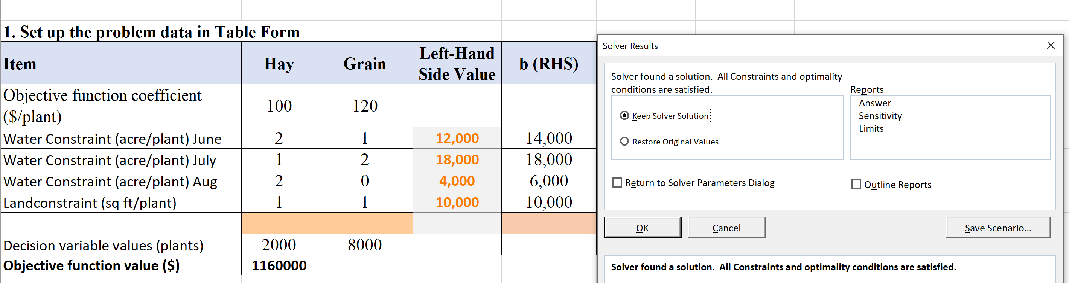

|  |  |  |  |  |  |  |  |
| --- | --- | --- | --- | --- | --- | --- | --- |
| **Title**  **(1)** | Absent  0 | Evidence of two or less  0 | Evidence of three  0 | Evidence of four  1 | Title – can assess main point from title alone; Name, Instructors’ Names, Course, Date, Neatly finished 1 | 1 |  |
| **Introduction**  **(3)** | Absent, no evidence  0 | There is no clear introduction or main topic.  1 | Introduction states the main topic but either:   1. Does not give a full overview, Or: 2. Too detailed, leading to annoying repetition later. 2 | The introduction states the main topic and previews the structure of the report.  2 | The introduction states the main topic and previews the structure of the report. Good overview of the problem and solution approach. Gives enough detail to motivate the reader to continue reading.  3 | 2 |  |
| **Organization and structural development of the idea**  **(10)** | No content provided.  0 | Paragraphs fail to develop the main idea. No section headers or guide to help the reader understand how material is organized. 1 – 5 | Organization of ideas not fully developed. Paragraphs lack supporting detail sentences. No transitions and/or ineffective section headers.  6 - 7 | Paragraph development present but not perfected. Each paragraph has sufficient supporting detail sentences. Few transitions. 8 | Writer demonstrates logic and sequencing of intro, procedure, results, and conclusions through well-developed section headers, paragraphs, and transitions. The first sentence of each paragraph is the summary sentence. 9 - 10 | 7 |  |
| **Technical Correctness**  **(70)** | Questions not addressed.  3 – 42% | The writer has no clue what they are talking about.  45 – 58% | Sketchy: left out required design points. Did not work on this as much as you should have, and it shows. Many important answers are incorrect.  61 – 79% | Discussion lacks adequate detail, but all the necessary points are covered and nearly all answers are correct.  82 – 88% | Provides what was explicitly asked for. The function of each piece is demonstrated to the reader in adequate, but not overwhelming, detail. Answers are correct and reasonable.  91 – 100% |  |  |
| 1. LP Model Formulation (5) | | | | |  |  |
| 1. Excel Solution (25) | | | | |  |  |
| 1. GAMS Solution (25) | | | | |  |  |
| D) Compare Excel and GAMS software and solutions (15) | | | | |  |  |

|  |  |  |  |  |  |  |  |
| --- | --- | --- | --- | --- | --- | --- | --- |
| **Category**  **(Max. Score)** | **No Evidence** | **Doesn’t Meet Standard** | **Nearly Meets Standard** | **Meets Standard** | **Exceeds Standard** | **Self- Score** | **Instructor Score** |
| **Word Usage and Format**  **(10)** | Not applicable | Numerous and distracting errors in punctuation, capitalization, spelling, sentence structure, word usage, significant figures, tables, and figures. Data vomited onto page(s). Unacceptable / unprofessional at the graduate level. 1 – 5 | Misspelled words, poor English grammar and word choice. Main body of report is either longer or significantly less than one page. Figures are too small and/or under-labeled, although they are usually of acceptable quality and focus. Tables incoherent or not cohesive. Bad font sizes. Too much or too little data in appendices. Could be improved by being more meticulous.  6 - 7 | Almost no errors in punctuation, capitalization, spelling, sentence structure, word usage, significant figures, and presentation of figures, tables, and appendices. Main body of report is one page or less  8 | Punctuation, capitalization, spelling, sentence structure, word usage, and significant figures all correct. Main body of report is one page or less. Clear, consistent fonts. Good word processing skills. Figures have adequate contrast. Informative figure and table titles and legends. Figures have appropriate axis tick spacing, labels, units, and legends. Table columns cohesive, labeled, and specify units. Document is stapled. Appendices, if provided, are separated by topic, and each have a title, discussion, and proper formatting and display of information 9 - 10 | 8 |  |
| **Conclusion**  **(4)** | Absent  0 | Incomplete and/or not focused. 1 | The conclusion does not adequately restate the main results. 2 | The conclusion restates the main results. 3 | The conclusion restates the main results, and is an effective summary. 4 | 4 |  |
| **References**  **(0)** | Absent  0 | Numerous errors, off-the-wall sources used. 0 | Some errors in citing format; more sources should be cited.  1 | Prior work cited with few errors.  2 | All prior work and data sources are cited in the correct format with no errors.  2 | NA | NA |
| **TOTAL** (100) |  | | | | |  |  |

Instructor Feedback: